Task 1: User Story reviewer

Steps:
*Extract a User Story from Jira.
*Pass the extracted User Story to your Langflow workflow.
*review the usestories by giving the prompt to the LLM.
*Copy the generated cURL command from Langflow.
*Import or execute the same request in Postman.
*Verify that the test cases generated through Postman match the output produced by Langflow.

Created Workflow in Lang
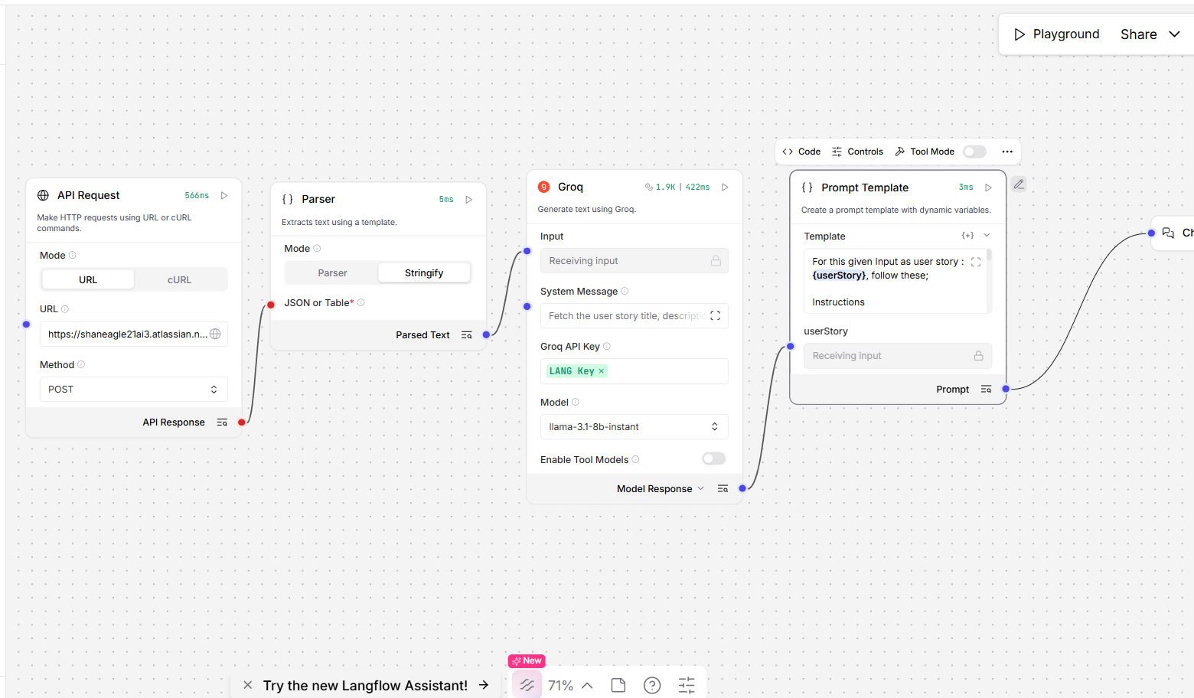
Output:
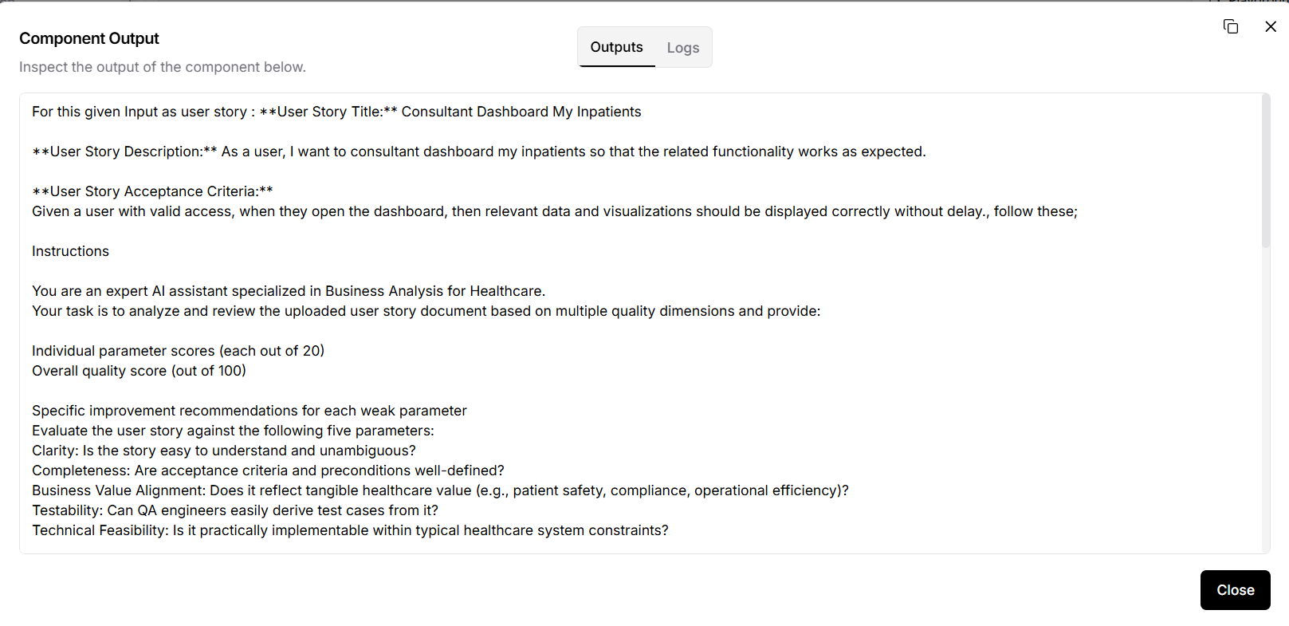
Postman
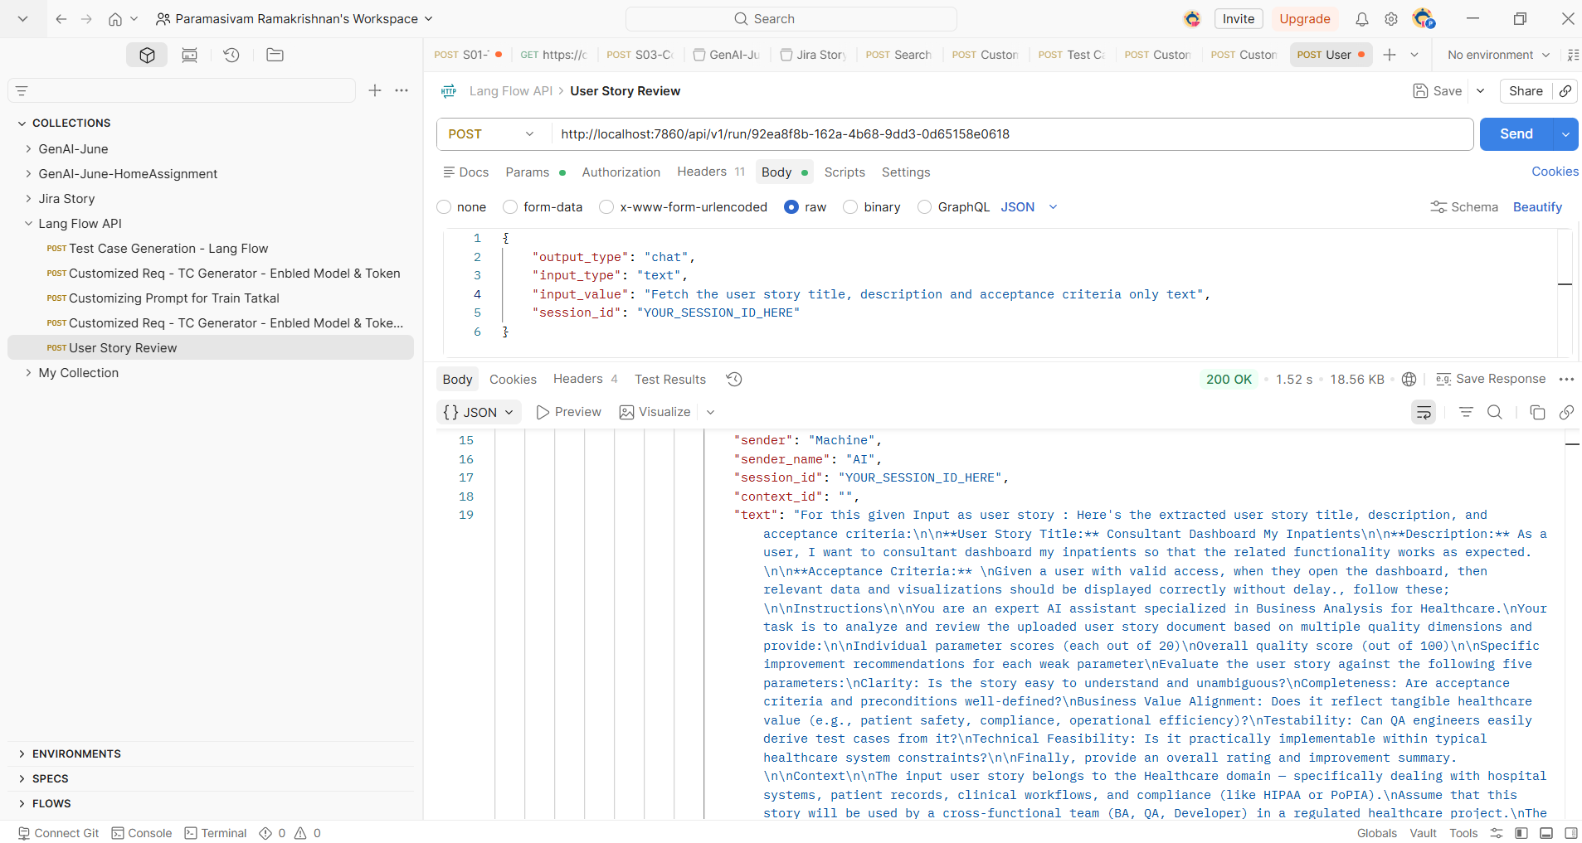

Both Output are equal
Second Assignment:
Task 2: File Text Extraction

* Read File (PDF or supported file format) and extract its text using Langflow.
* Copy the generated cURL command from Langflow.
* Execute the same request in Postman and verify that the extracted text matches the Langflow output.
Langflow:
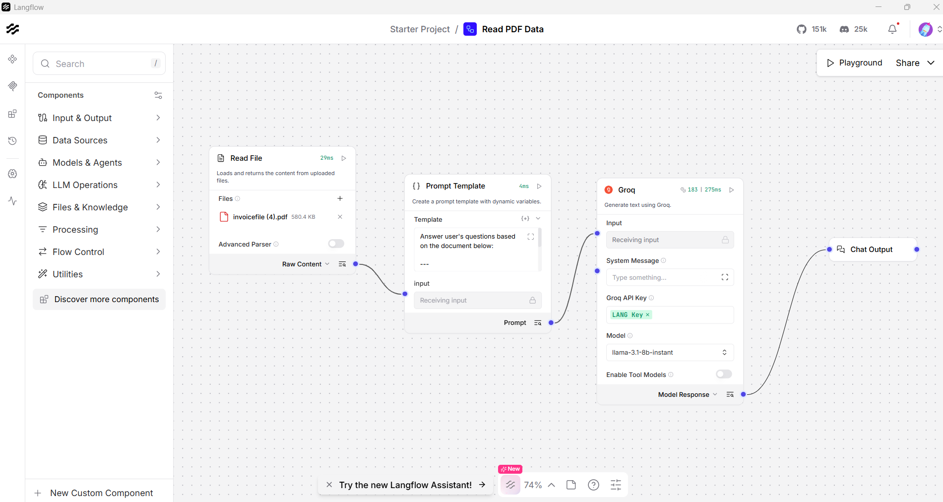
Postman
